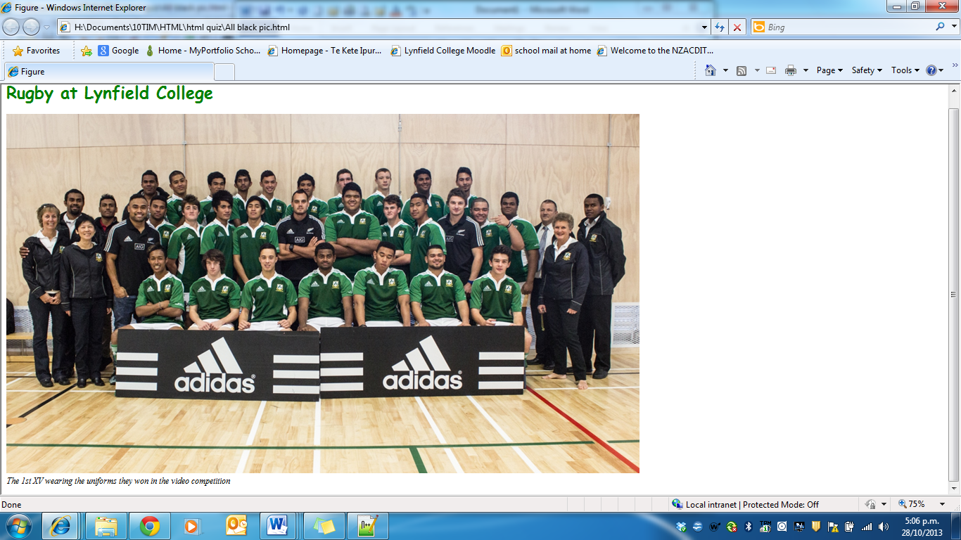

Figure title for the page

**Create the above html page and display it in your browser.**

To do this you will have to:

* Copy the *Lynfield College 1st XV and All blacks*.jpg to **your html images folder**
* Give the page a title -. Figure - within title tags which come below the head. Remember to close the head after you have closed the title tag.
* Open a body tag and include a heading style with the following
  + Font is Comic Sans MS
  + Colour is green
  + Font size is 24px
  + Title is Rugby at Lynfield College.
  + Remember to close the h1 style/
* The image is lynfield College 1st XV and All blacks.jpg
  + Size is width 1200 and the height is 600
  + Add a alt attribute which says: Photograph of the Lynfield College 1st XV with some All Blacks
  + Add a line break tag so that the caption goes underneath the photo.
  + Add a figcaption tag which says The 1st XV wearing the uniforms they won in the video competition. This is to be in italics.
* Close the body tag
* Close the Html tag.

**Extra for rugby fans – name the All Blacks and the sides they play for.**